**SIT323 Practical Software Development**

**Assessment Task 2**

**Portfolio Document**

Submitted by: Foever Cui

Subject: SIT323 Practical Software Development Assessment Task 1

Delivered on: Oct 3rd, 2016

**Content**

Introduction 3

Background and Purpose 3

Document Scope 3

Software Scope 3

Read a crozzle TXT file and a configuration TXT file to automatically create a new crozzle. 3

Compute and display the score of a new crozzle. 3

Create a valid crozzle based on a wordlist and constraints. 4

Saved File 4

Methods 4

Create Crozzle (Greedy Algorithm) 4

Calculating Score 5

Calculating Time 5

Test Methods 5

Display 5

Save File 5

Assumptions 6

Expectations 6

Test Section 6

Section One – Test One 6

Summary 6

Output 6

Section Two – Test Two 9

Summary 9

Output 10

Section Three – Test Three 11

Summary 11

Summary 12

Appendix – Copy of Input Files 13

Section One – Test one 13

Configuration File - Test 1 - EASY Configuration.txt 13

Crozzle File - Test 1 - EASY.txt 14

Section Two – Test Two 15

Configuration File - Test 2 - MEDIUM Configuration.txt 15

Crozzle File - Test 2 - MEDIUM.txt 16

Section Three – Test Three 17

Configuration File - Test 3 - HARD Configuration.txt 17

Crozzle File - Test 3 Crozzle.txt 18

# Introduction

## Background and Purpose

Crozzle is a kind of word game, which starts with an empty grid and a list of words. The score can be calculated according to the point of each word and letter. The software named crozzle can create new crozzle correctly and compute the highest for this crozzle according to chosen file. Users should click the menu to choose a configuration file and then choose a crozzle file. They can also click “help” to know how to operate the software. Then related information will display on the screen. This document aims to show the software scope and output of this software in details, including GUI output and related file contents.

## Document Scope

In this document, the scope of creating a crozzle and methods to achieve it will be introduced. There will be three sections in document body. Each section contains the summary and output of each particular test. In addition, three sections which include the crozzle files of particular test will also be shown in appendix.

## Software Scope

### Read a crozzle TXT file and a configuration TXT file to automatically create a new crozzle.

What should be addressed is that the most important of this program is to read files and create new crozzle. There are necessary information in such files which will be used to create and validate a crozzle.

* Crozzle file
* Difficulty level, such as “EASY”, “MEDIUM”, “HARD”
* Number of all words.
* Word list.
* Configuration file
* The first line shows the group of the crozzle in the pattern like “GROUPSPERCROZZLELIMIT=number”..
* The second line shows the points that can be scored for each word in the pattern like “POINTSPERWORD=number”.
* The next 26 lines show the point that can be scored for each intersection letter in the pattern like “INTERSECTING: letter=number”.
* The next 26 lines show the point that can be scored for each non-intersection letter in the pattern like “NONINTERSECTING: letter=number”.

### Compute and display the score of a new crozzle.

According to the word list in crozzle file and score in configuration file. The crozzle can be displayed and the score can be computed and shown on the screen.

### Create a valid crozzle based on a wordlist and constraints.

There are various constrains according different aspects and different level, which have been introduced in following content.

* Crozzle constraints
* **Common**: the word displayed in crozzle should be found in word list.
* A word cannot be inserted in the crozzle more than once.
* The word should be within the edge of the crozzle.
* The number of group should match the configuration file.
* **Easy**: a horizontal word is limited to intersecting at least 1 and at most 2 other vertical words.
* A vertical word is limited to intersecting at least 1 and at most 2 other horizontal words.
* A horizontal/vertical word cannot touch any other horizontal/vertical word.
* **Medium**: a horizontal word is limited to intersecting at least 1 and at most 3 other vertical words.
* A vertical word is limited to intersecting at least 1 and at most 3 other horizontal words.
* **Hard**: a horizontal word must intersect 1 or more vertical words.
* A vertical word must intersect 1 or more horizontal words.
* Time constraints
* The crozzle should be displayed and score need to be computed within five minutes.
* Score constraints
* The final score need to be the highest one which can be computed based on configuration data.

### Saved File

Once the crozzle has been generated, display, and the score have been computed, the entire crozzle need to be saved in a file.

## Methods

### Create Crozzle (Greedy Algorithm)

In order to valid the crozzle according the validation scope which described above, some method has been considered to tackle these problems.

* Crozzle file
* Obtain the length of word list in crozzle, which can be used to be compared with the number in the first line.
* Configuration file
* Write regular expression to determine whether the content is valid.
* Crozzle create
* **Step 1**: Calculating the score of each word in word list and sort them based on computed score.
* **Step 2**: Scan the whole sorted list and find two words which can insert with each other. Given them initial axis and direction and save to a 2-demission list.
* **Step 3**: Based on the group which has been generated before, scan the group list and judge whether there are groups which can insert with each other.
* **Step 4**: If there are two groups which can insert with each other, changing their direction and axis and validate the added list.
* **Step 5**: Taking advantage of recurs function to repeat step 3 and generate final 3-demission list, which store the possible group.
* **Step 6**: Sort the possible 2-demession according to their score word group and get the first one which is the highest one.

### Calculating Score

The score can be calculated according to the contents in configuration file. Storing the score of each letter in an array whose length is 52. Loop the word list to determine whether the letter is intersection and store it in correct index. The final score of crozzle is the product of two arrays.

### Calculating Time

After open file, current time will be got, and after the crozzle creating, there will be also a time. Then the time cost is the difference of these two time.

### Test Methods

There are five test methods which have been used to test functions of this software.

**Try Method**

“Try” methods have been used to catch exceptions when running the software.

### Display

There is an interface which developed using widgets in visual studio. Users can click menu to choose file. The crozzle will display in the webbrowser. The score and time will also show on the screen.

In order to show the crozzle in a reasonable approach, there is a table written by html to display the crozzle dynamically, each letter will insert in the correct grid.

### Save File

There is a function which can write crozzle information into a file according to the path and file name. If the file exists, the contents will cover old conten.

## Assumptions

There are some assumptions which should be considered when test and run the software.

* The “Open Configuration” need to be clicked firstly and then the “Open File”.

## Expectations

The final software should allow users to choose configuration file and crozzle file. Then the software can generated a new crozzle based on the data in files. In addition, score and time cost will display on the screen.

# Test Section

## Section One – Test One

### Summary

The highest score of test one is 41, the time will be displayed on web browser and console. In addition, the crozzle has been written in Saved Crozzle/EASY.txt.

### Output

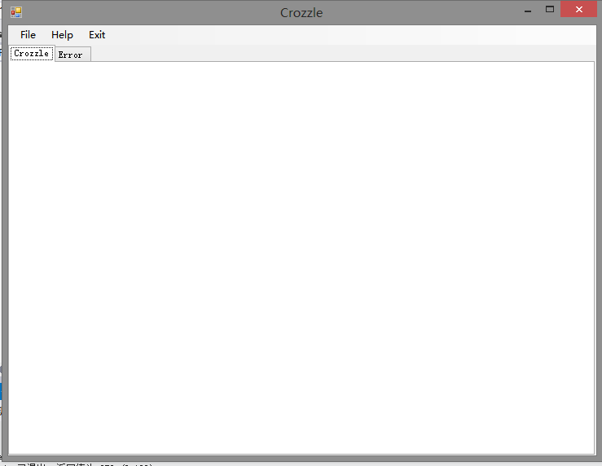

Figure 1 The GUI

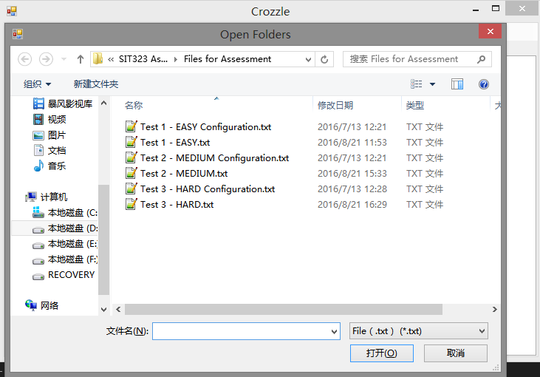

Figure 2 OpenFileDialog and Choose Configuration File

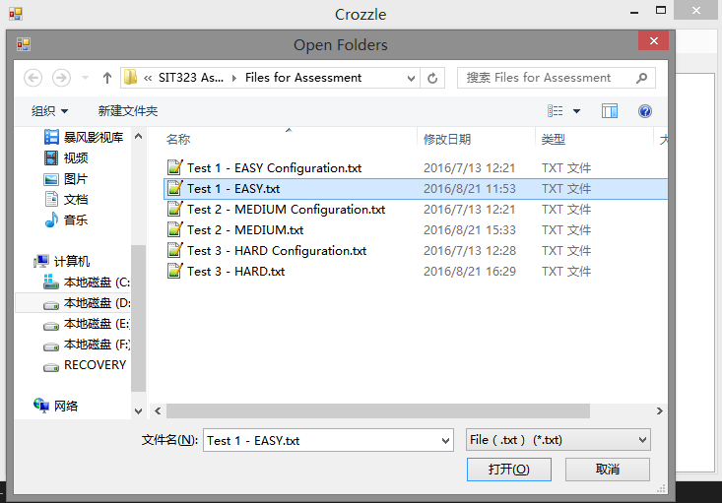

Figure 3 OpenFileDialog and Choose Crozzle File

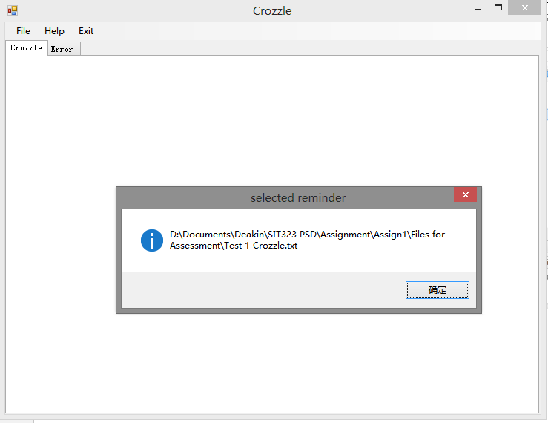

Figure 4 Display File Name

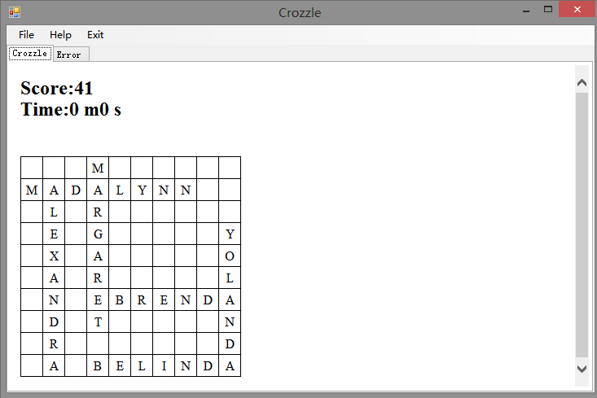

Figure 5 Test 1 Output Crozzle

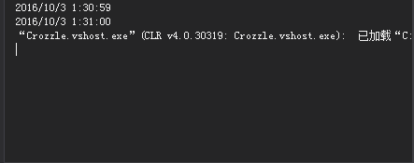

Figure 6 Test 1 Time Displayed in Console

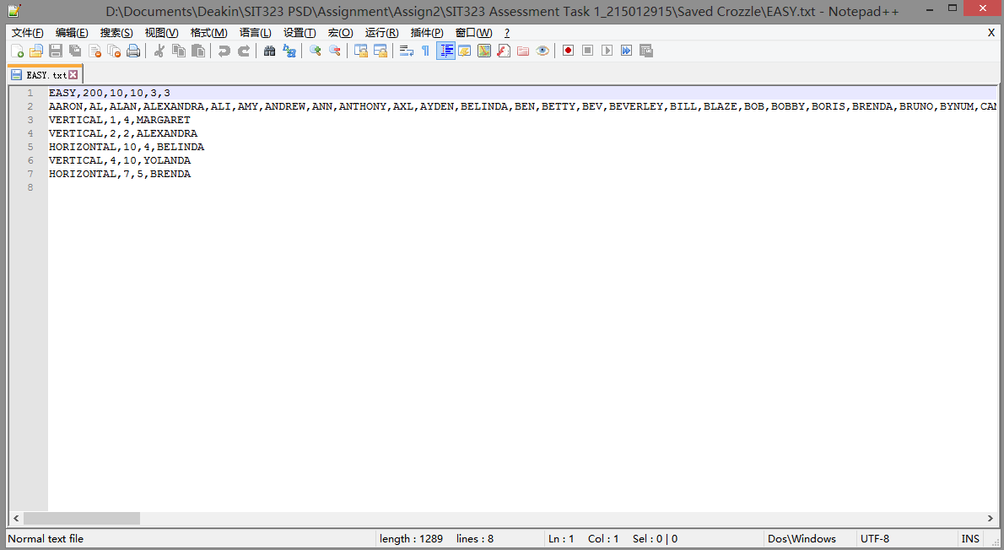

Figure 7 Test 1 Saved Cozzle File

## Section Two – Test Two

### Summary

The highest score of test one is 708, the time will be displayed on web browser and console. In addition, the crozzle has been written in Saved Crozzle/MEDIUM.txt.

### Output

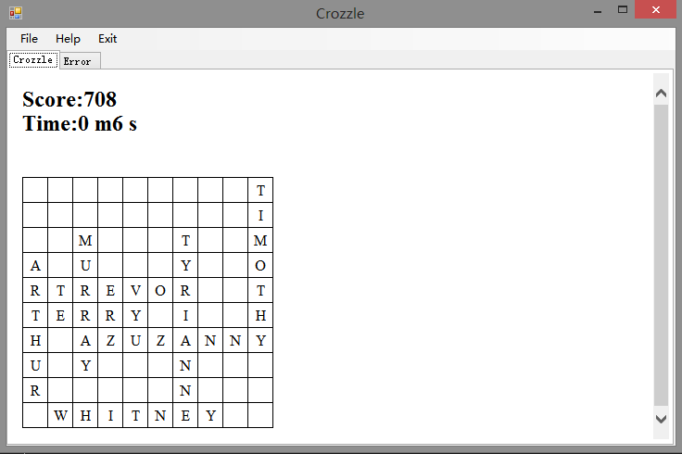

Figure 8 Test 2 Output Crozzle

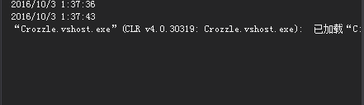

Figure 9 Test 2 Time Displayed in Console

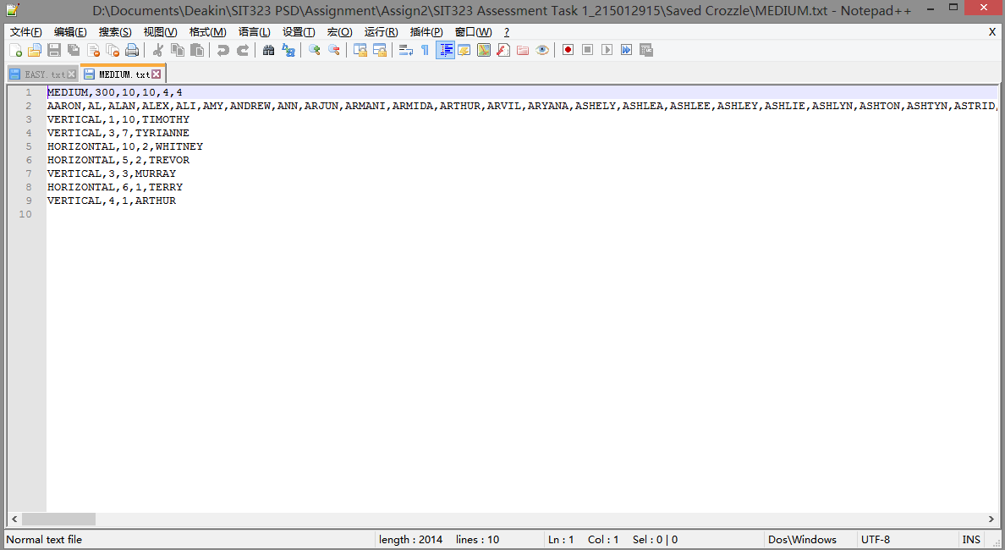

Figure 10 Test 2 Saved Crozzle File

## Section Three – Test Three

### Summary

The highest score of test one is 502, the time will be displayed on web browser and console. In addition, the crozzle has been written in Saved Crozzle/MEDIUM.txt.

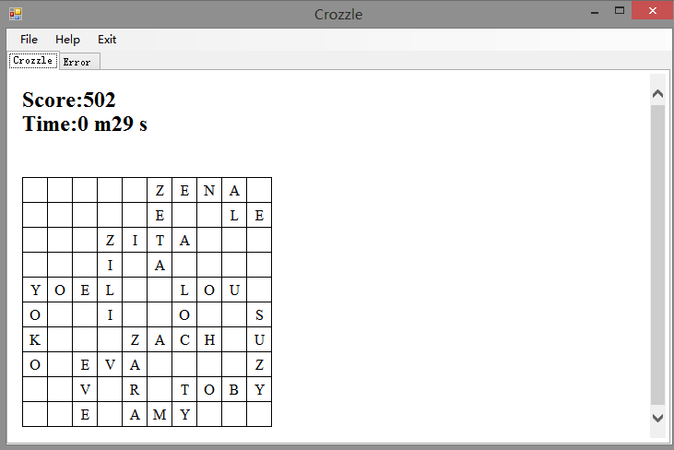

Figure 11 Test 3 Output Crozzle

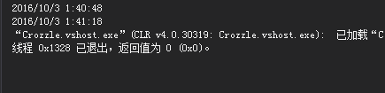

Figure 12 Test 3 Time Displayed on Console

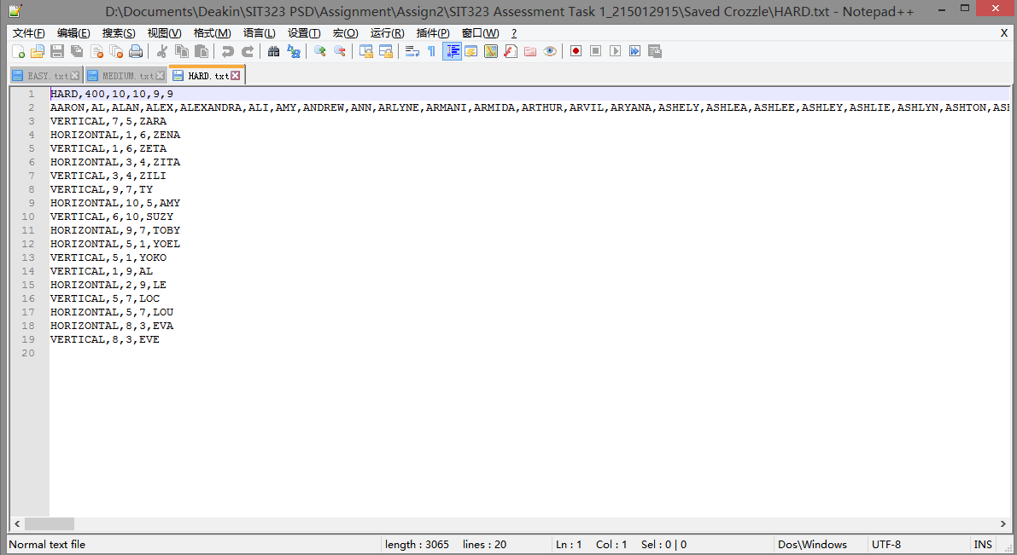

Figure 13 Test 3 Save Crozzle

# Summary

In conclusion, the software has achieved the expected results. Open File dialog has been used so that user can select configuration file and crozzle file and the file name can be obtained. Crozzle can be generated according the files and the highest score can be computed. In addition, the crozzle is valid and created within required time. Finally, the crozzle can be saved in a txt file.

# Appendix – Copy of Input Files

## Section One – Test one

### Configuration File - Test 1 - EASY Configuration.txt

GROUPSPERCROZZLELIMIT=1000

POINTSPERWORD=0

INTERSECTING:A=1

INTERSECTING:B=1

INTERSECTING:C=1

INTERSECTING:D=1

INTERSECTING:E=1

INTERSECTING:F=1

INTERSECTING:G=1

INTERSECTING:H=1

INTERSECTING:I=1

INTERSECTING:J=1

INTERSECTING:K=1

INTERSECTING:L=1

INTERSECTING:M=1

INTERSECTING:N=1

INTERSECTING:O=1

INTERSECTING:P=1

INTERSECTING:Q=1

INTERSECTING:R=1

INTERSECTING:S=1

INTERSECTING:T=1

INTERSECTING:U=1

INTERSECTING:V=1

INTERSECTING:W=1

INTERSECTING:X=1

INTERSECTING:Y=1

INTERSECTING:Z=1

NONINTERSECTING:A=1

NONINTERSECTING:B=1

NONINTERSECTING:C=1

NONINTERSECTING:D=1

NONINTERSECTING:E=1

NONINTERSECTING:F=1

NONINTERSECTING:G=1

NONINTERSECTING:H=1

NONINTERSECTING:I=1

NONINTERSECTING:J=1

NONINTERSECTING:K=1

NONINTERSECTING:L=1

NONINTERSECTING:M=1

NONINTERSECTING:N=1

NONINTERSECTING:O=1

NONINTERSECTING:P=1

NONINTERSECTING:Q=1

NONINTERSECTING:R=1

NONINTERSECTING:S=1

NONINTERSECTING:T=1

NONINTERSECTING:U=1

NONINTERSECTING:V=1

NONINTERSECTING:W=1

NONINTERSECTING:X=1

NONINTERSECTING:Y=1

NONINTERSECTING:Z=1

### Crozzle File - Test 1 - EASY.txt

EASY,200,10,10,0,0

AARON,AL,ALAN,ALEXANDRA,ALI,AMY,ANDREW,ANN,ANTHONY,AXL,AYDEN,BELINDA,BEN,BETTY,BEV,BEVERLEY,BILL,BLAZE,BOB,BOBBY,BORIS,BRENDA,BRUNO,BYNUM,CAM,CATHERINE,CHAZ,CLIVE,CON,CONNOR,CONWAY,CRUZ,DALE,DAN,DAVE,DAVID,DAVY,DAWN,DENNIS,DENZIL,DOM,DON,DREMA,DREW,ED,EDDY,EDITH,EDWARD,ELIZABET,ELVIS,EMMA,ENZO,ERICA,EVA,EVAN,EZZARD,FAWN,FRED,GARY,GIOVANNY,GLENDA,GRAHAM,GWEN,GWYN,HOPE,HUEY,HUXLEY,IAN,ISA,IVAN,IVON,IZA,JACK,JAKE,JAQUELINE,JILL,JIM,JOHN,KARL,KAY,KAYNE,KELVIN,KEVIN,LE,LEO,LEON,LES,LEWIS,LILA,LIZ,LOC,LOU,LU,LUCILE,LULU,MADALYNN,MAL,MARGARET,MARK,MARY,MATHEW,MATTHEW,MAVIS,MAY,MICHELLE,MITZI,MURRAY,NED,NEIL,NOE,NOEL,OLIVE,OMAR,ORAN,OSCAR,OWEN,OWENS,OZZIE,PAM,PENELOPE,PENNY,PETER,PHEBE,QUINCY,QUINTY,RACHELLE,RAS,RAY,REMI,RENTON,REX,RICHARD,ROBERT,ROD,ROGER,RON,ROWAN,ROY,ROZY,RYDER,SALLY,SAM,SARAH,SHELDON,SPENCER,STEPHEN,STEVE,STEVEN,SUE,SUZY,SYLVIA,TAMMY,TEDDY,TERRY,TIMOTHY,TOBY,TODD,TOM,TRACEY,TREVOR,TY,TYRIANNE,VELVET,VERA,VERN,VIC,VICK,VICKY,VICTOR,WADE,WALLY,WALT,WENDY,WES,WESLEY,WHITNEY,WILL,WILLY,WILMA,WYNNIE,XAVIER,XENA,XIA,XIANG,YEE,YOEL,YOKO,YOLANDA,YOSEF,ZACH,ZACK,ZARA,ZELDA,ZENA,ZETA,ZEUS,ZILI,ZOLA,ZORBA,ZUZANNY

## Section Two – Test Two

### Configuration File - Test 2 - MEDIUM Configuration.txt

GROUPSPERCROZZLELIMIT=1000

POINTSPERWORD=0

INTERSECTING:A=1

INTERSECTING:B=2

INTERSECTING:C=3

INTERSECTING:D=4

INTERSECTING:E=5

INTERSECTING:F=6

INTERSECTING:G=7

INTERSECTING:H=8

INTERSECTING:I=9

INTERSECTING:J=10

INTERSECTING:K=11

INTERSECTING:L=12

INTERSECTING:M=13

INTERSECTING:N=14

INTERSECTING:O=15

INTERSECTING:P=16

INTERSECTING:Q=17

INTERSECTING:R=18

INTERSECTING:S=19

INTERSECTING:T=20

INTERSECTING:U=21

INTERSECTING:V=22

INTERSECTING:W=23

INTERSECTING:X=24

INTERSECTING:Y=25

INTERSECTING:Z=26

NONINTERSECTING:A=1

NONINTERSECTING:B=2

NONINTERSECTING:C=3

NONINTERSECTING:D=4

NONINTERSECTING:E=5

NONINTERSECTING:F=6

NONINTERSECTING:G=7

NONINTERSECTING:H=8

NONINTERSECTING:I=9

NONINTERSECTING:J=10

NONINTERSECTING:K=11

NONINTERSECTING:L=12

NONINTERSECTING:M=13

NONINTERSECTING:N=14

NONINTERSECTING:O=15

NONINTERSECTING:P=16

NONINTERSECTING:Q=17

NONINTERSECTING:R=18

NONINTERSECTING:S=19

NONINTERSECTING:T=20

NONINTERSECTING:U=21

NONINTERSECTING:V=22

NONINTERSECTING:W=23

NONINTERSECTING:X=24

NONINTERSECTING:Y=25

NONINTERSECTING:Z=26

### Crozzle File - Test 2 - MEDIUM.txt

MEDIUM,300,10,10,0,0

AARON,AL,ALAN,ALEX,ALI,AMY,ANDREW,ANN,ARJUN,ARMANI,ARMIDA,ARTHUR,ARVIL,ARYANA,ASHELY,ASHLEA,ASHLEE,ASHLEY,ASHLIE,ASHLYN,ASHTON,ASHTYN,ASTRID,ATHENA,AUBREE,AUBREY,AUBRIE,AUDREY,AURORA,AURORE,AUSTIN,AXL,AYDEN,BELINDA,BEN,BETTY,BEV,BEVERLEY,BILL,BLAZE,BOB,BOBBY,BORIS,BRENDA,BRIGGS,BRODIE,BROGAN,BROOKS,BRUNO,BRYANT,BRYCEN,BRYSEN,BRYSON,BRYTON,BUDDIE,BUFORD,BURLEY,BURNEY,BURNIE,BURREL,BURTON,BUSTER,BUTLER,BYNUM,CAESAR,CAIDEN,CALLAN,CAM,CARA,CHAZ,CLIVE,CON,CONNOR,CONWAY,CRUZ,DALE,DAN,DAVE,DAVID,DAVY,DAWN,DAYANA,DEANNA,DEANNE,DEASIA,DEBBIE,DEBBRA,DEBERA,DEBORA,DEBRAH,DEEANN,DEEDEE,DEETTA,DEIDRA,DEIDRE,DELCIE,DELIAH,DELILA,DELINA,DELISA,DELLAR,DELLIA,DELLIE,DELOIS,DELORA,DELPHA,DELSIE,DENNIS,DENZIL,DOM,DON,DOT,DREW,ED,EDDY,EDITH,EDWARD,ELIZABETH,ELVIS,EMMA,ENZO,ERICA,ERLENE,ERLINE,ERMINA,ERMINE,ERNEST,ERYKAH,ESTELA,ESTELL,ESTHER,ETHYLE,EUDORA,EUGENE,EUNICE,EVA,EVALYN,EVAN,EVELIN,EVELYN,EVERLY,EVETTE,EVONNE,EZZARD,FALLON,FANNIE,FANNYE,FARRAH,FATIMA,FAWN,FELICE,FELIPA,FINLEY,FRED,GARY,GIOVANNY,GLENDA,GRAHAM,GWEN,GWYN,HARVY,HOWARD,HUXLEY,IAN,IVA,IVAN,IVON,IZA,JACK,JAKE,JAQUELINE,JILL,JO,JUDY,KARL,KAY,KAYLAH,KAYLAN,KAYLEE,KAYLEN,KAYNE,KELVIN,KEVIN,LE,LEO,LEON,LES,LEWIS,LILA,LIZ,LOC,LOU,LU,LUCILE,LULU,MADALYNN,MAL,MARGARET,MARK,MARY,MATHEW,MATTHEW,MAVIS,MAY,MICHELLE,MITZI,MURRAY,NAOMI,NED,NOE,NOEL,OLIVE,OMAR,ORAN,OSCAR,OWEN,OWENS,OZZIE,PAM,PENELOPE,PENNY,PETER,PHEBE,QUINCY,QUINTY,RACHELLE,RAE,RAY,REMY,RENTON,REX,RICHARD,ROBERT,ROD,ROGER,RON,ROWAN,ROY,ROZY,RYLEY,SALLY,SAM,SARAH,SHELDON,SOPHIE,STEPHEN,STEVE,STEVEN,SUE,SUZY,SYLVIA,TAMMY,TED,TERRY,TIMOTHY,TOBY,TODD,TOM,TRACEY,TREVOR,TY,TYRIANNE,VELVET,VERA,VELDA,VIC,VICK,VICKY,VICTOR,WADE,WALLY,WALT,WENDY,WES,WESLEY,WHITNEY,WILL,WILLY,WILMA,WYNNIE,XAVIER,XENA,XIA,XIANG,YEE,YOEL,YOKO,YOLANDA,YORK,ZACH,ZACK,ZARA,ZELIA,ZENA,ZETA,ZEUS,ZILI,ZOLA,ZORBA,ZUZANNY

## Section Three – Test Three

### Configuration File - Test 3 - HARD Configuration.txt

GROUPSPERCROZZLELIMIT=1

POINTSPERWORD=10

INTERSECTING:A=1

INTERSECTING:B=2

INTERSECTING:C=2

INTERSECTING:D=2

INTERSECTING:E=1

INTERSECTING:F=2

INTERSECTING:G=2

INTERSECTING:H=2

INTERSECTING:I=1

INTERSECTING:J=4

INTERSECTING:K=4

INTERSECTING:L=4

INTERSECTING:M=4

INTERSECTING:N=4

INTERSECTING:O=1

INTERSECTING:P=8

INTERSECTING:Q=8

INTERSECTING:R=8

INTERSECTING:S=8

INTERSECTING:T=8

INTERSECTING:U=1

INTERSECTING:V=16

INTERSECTING:W=16

INTERSECTING:X=32

INTERSECTING:Y=32

INTERSECTING:Z=64

NONINTERSECTING:A=0

NONINTERSECTING:B=0

NONINTERSECTING:C=0

NONINTERSECTING:D=0

NONINTERSECTING:E=0

NONINTERSECTING:F=0

NONINTERSECTING:G=0

NONINTERSECTING:H=0

NONINTERSECTING:I=0

NONINTERSECTING:J=0

NONINTERSECTING:K=0

NONINTERSECTING:L=0

NONINTERSECTING:M=0

NONINTERSECTING:N=0

NONINTERSECTING:O=0

NONINTERSECTING:P=0

NONINTERSECTING:Q=0

NONINTERSECTING:R=0

NONINTERSECTING:S=0

NONINTERSECTING:T=0

NONINTERSECTING:U=0

NONINTERSECTING:V=0

NONINTERSECTING:W=0

NONINTERSECTING:X=0

NONINTERSECTING:Y=0

NONINTERSECTING:Z=0

### Crozzle File - Test 3 Crozzle.txt

HARD,400,10,10,0,0

AARON,AL,ALAN,ALEX,ALEXANDRA,ALI,AMY,ANDREW,ANN,ARLYNE,ARMANI,ARMIDA,ARTHUR,ARVIL,ARYANA,ASHELY,ASHLEA,ASHLEE,ASHLEY,ASHLIE,ASHLYN,ASHTON,ASHTYN,ASTRID,ATHENA,AUBREE,AUBREY,AUBRIE,AUDREY,AURORA,AURORE,AUSTIN,AXL,AYDEN,BELINDA,BEN,BETTY,BEV,BEVERLEY,BILL,BLAZE,BOB,BOBBY,BORIS,BRENDA,BRIGGS,BRODIE,BROGAN,BROOKS,BRUNO,BRYANT,BRYCEN,BRYSEN,BRYSON,BRYTON,BUDDIE,BUFORD,BURLEY,BURNEY,BURNIE,BURREL,BURTON,BUSTER,BUTLER,BYNUM,CAESAR,CAIDEN,CALLAN,CAM,CARA,CHAZ,CLIVE,CON,CONNOR,CONWAY,CRUZ,DALE,DAN,DAVE,DAVID,DAVY,DAX,DAYANA,DEANNA,DEANNE,DEASIA,DEBBIE,DEBBRA,DEBERA,DEBORA,DEBORRAH,DEBRAH,DEEANN,DEEDEE,DEETTA,DEIDRA,DEIDRE,DELCIE,DELIAH,DELILA,DELINA,DELISA,DELLAR,DELLIA,DELLIE,DELOIS,DELORA,DELPHA,DELPHINE,DELSIE,DEMETRIA,DENNIS,DENZIL,DESTINEE,DESTINEY,DEYANIRA,DOM,DOMENICA,DOMINQUE,DON,DORATHEA,DOROTHEA,DREMA,DREW,DRUCILLA,DRUSILLA,ED,EDDY,EDITH,EDWARD,ELEANORA,ELEANORE,ELEONORA,ELEONORE,ELFRIEDA,ELIZABET,ELIZABETH,ELIZBETH,ELVIS,EMMA,EMMALINE,EMMALYNN,EMMELINE,ENZO,ERICA,ERLENE,ERLINE,ERMINA,ERMINE,ERNEST,ERYKAH,ESTEFANI,ESTEFANY,ESTELA,ESTELL,ESTHER,ESTRELLA,ETHELENE,ETHYLE,EUDORA,EUGENE,EUNICE,EUPHEMIA,EVA,EVALYN,EVAN,EVE,EVELYN,EVERLY,EVETTE,EVONNE,EZZARD,FALLON,FANNIE,FANNYE,FARRAH,FATIMA,FAWN,FELICE,FELICITY,FELIPA,FERNANDA,FILOMENA,FINLEY,FRED,GARY,GIOVANNY,GLENDA,GRAHAM,GWEN,GWYN,HARRISON,HARTWELL,HARVY,HERSCHEL,HERSHELL,HEZEKIAH,HILLIARD,HOWARD,HUMBERTO,HUMPHREY,HUXLEY,IAN,IGNATIUS,IMMANUEL,ISA,IVAN,IVON,IZA,JACK,JAKE,JAMARCUS,JAMARION,JAQUELINE,JEDEDIAH,JEDIDIAH,JEFFEREY,JENNIFER,JENNINGS,JERAMIAH,JEREMIAH,JERIMIAH,JERMAINE,JILL,JIM,JOHATHAN,JOHN,JOHNPAUL,JONATHAN,JONATHON,JOSELUIS,JOSEPHUS,KARL,KATHLEEN,KAY,KAYLAH,KAYLAN,KAYLEE,KAYLEN,KAYNE,KELVIN,KENDRICK,KENYATTA,KEVIN,KEYSHAWN,LE,LEO,LEON,LES,LEW,LEWIS,LIZ,LOC,LOU,LU,LUCILE,LULU,MADALYNN,MAL,MARGARET,MARIANNA,MARIANNE,MARIBETH,MARICELA,MARIETTA,MARILYNN,MARISELA,MARJORIE,MARK,MARLEIGH,MARQUITA,MARY,MARYANNE,MARYBETH,MARYJANE,MATHEW,MATHILDA,MATHILDE,MATTHEW,MAVIS,MAY,MAYBELLE,MCKENZIE,MCKINLEY,MECHELLE,MELISSIA,MELLISSA,MERCEDES,MEREDITH,MERRILEE,MICHAELA,MICHAELE,MICHELLE,MIGDALIA,MILAGROS,MINERVIA,MISSOURI,MITZI,MURRAY,NANNETTE,NAOMI,NATHALIA,NATHALIE,NEIL,NICHELLE,NICHOLAS,NOE,NOEL,OLIVE,OMAR,ORAN,OSCAR,OWEN,OWENS,OZZIE,PAM,PATIENCE,PATRICIA,PAULETTA,PENELOPE,PENNY,PETER,PHEBE,QUINCY,QUINTY,RACHELLE,RAS,RAY,REMI,RENTON,REX,RICHARD,ROBERT,ROD,ROGER,RON,ROWAN,ROY,ROZY,RYDER,SALLY,SAM,SARAH,SHELDON,SOPHIE,STEPHEN,STEVE,STEVEN,SUE,SUZY,SYLVIA,TAMMY,TED,TERRY,TEX,TOBY,TODD,TOM,TRACEY,TREVOR,TY,TYRIANNE,VELVET,VERA,VERN,VIC,VICK,VICKY,VICTOR,WADE,WALLY,WALT,WENDY,WES,WESLEY,WHITNEY,WILL,WILLY,WILMA,WYNNIE,XAVIER,XENA,XIA,XIANG,YEE,YOEL,YOKO,YOLANDA,YORK,ZACH,ZACK,ZARA,ZED,ZENA,ZETA,ZITA,ZILI,ZOLA,ZORBA,ZUZANNY